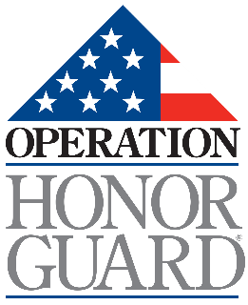
Operation Honor Guard’s Whistleblower Policy
Reviewed: April 1, 2025
This Whistleblower Policy of Operation Honor Guard:
- Encourages volunteers to come forward with credible information regarding illegal practices or serious violations of adopted policies;
- Specifies that Operation Honor Guard will protect individuals from retaliation; and
- Identifies how and where such information can be reported.
1. Encouragement of Reporting
Operation Honor Guard encourages complaints, reports, or inquiries about illegal practices or serious violations of organizational policies—including misconduct by Operation Honor Guard, its leadership, or others acting on its behalf. Examples include, but are not limited to:
- Financial improprieties
- Accounting or audit irregularities
- Ethical violations
- Other illegal or improper activities
Complaints related to issues such as discrimination or harassment should be reported through the organization’s established grievance channels, unless those channels are directly implicated in the wrongdoing. This policy is not intended to serve as an appeal process for decisions made through other established mechanisms.
2. Protection from Retaliation
Operation Honor Guard strictly prohibits retaliation against any volunteer who makes a good-faith complaint, report, or inquiry under this policy—or who participates in any resulting investigation or review. This protection also applies if the concern raised turns out to be mistaken, as long as it was made in good faith.
However, Operation Honor Guard reserves the right to take disciplinary action against individuals who knowingly make false, malicious, or vexatious complaints, or who otherwise abuse the policy.
3. Where to Report
Complaints, reports, or inquiries may be made confidentially—or anonymously—and should include sufficient detail to allow for an effective investigation. Reports should be submitted to a member of the Board of Directors. Operation Honor Guard will ensure a prompt, discreet, and objective review or investigation of the matter.
Volunteers should understand that vague or anonymous reports lacking specific information may limit the organization’s ability to respond appropriately.

