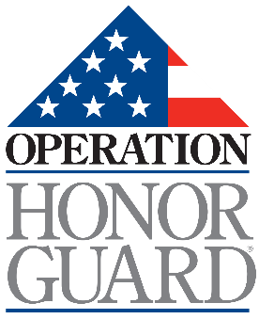
Our Privacy Promise to You
Reviewed: April 1, 2025
Since our inception in 2016, our stakeholders have trusted Operation Honor Guard (OHG) with their personal information. Whether you are a donor, a volunteer, an organization, or a community partner, our commitment to conducting business with integrity and protecting your privacy remains at the heart of our Privacy Promise.
We Respect Your Confidentiality
OHG requires that your personal information be held in strict confidence. We use your information only for its intended business purpose. We do not sell or trade your information to other organizations or individuals.
We Protect Your Information
OHG takes every possible measure to ensure that your information is not compromised in any way. If you participate in one of our programs, and with your permission, we may provide a participant list to those attending the class. This list may include your name, title, agency, and email address. Other than as indicated, no one outside of OHG staff has access to your information. Access is provided to specific funding sources only when required by contractual obligations.
Our Privacy Promise also extends to our website. Online event registration information is transmitted via a secure server using encryption technology. Some online forms are created using trusted third-party software providers, such as BluePay, which also utilize encryption technology.
If you choose to email us, we may retain your message, our response, and your email address as part of our ongoing customer service. We reserve the right to contact you following your inquiry and may send future emails and/or surveys about OHG. You may notify us via email if you wish to discontinue electronic communications.
We Keep Accurate Records
We maintain your personal information as accurately, completely, and up to date as necessary to fulfill the purpose(s) for which it was provided. Upon written request, we will remove your information from our databases, except where legislation or regulations require us to retain it (e.g., charitable giving history for tax purposes).
If you have any questions about our website or Privacy Promise, please contact us at (844) 409-1049 or by email at info@operationhonorguard.us.

